HUMAN TRACKING ROBOTIC BOT WITH MULTI-CONTROL SYSTEM USING IOT

1Dr. A. Vijayaraj

Associate Professor,

Department of IT,

R.M.K. Engineering College,

*RSM Nagar, Kavaraipettai,*

*Chennai- 601 206.*

[satturvijay@gmail.com](mailto:satturvijay@gmail.com)

4Tinku Abenash T

Department of Information Technology, R.M.K. Engineering College

[tink22109.it@rmkec.ac.in](mailto:tink22109.it@rmkec.ac.in)

2Shai Kumar R

Department of Information Technology, R.M.K. Engineering College

[shai22093.it@rmkec.ac.in](mailto:shai22093.it@rmkec.ac.in)

5Gopi Krishnan L

Department of Information Technology, R.M.K. Engineering College

[gopi21118.it@rmkec.ac.in](mailto:gopi21118.it@rmkec.ac.in)

3Santhosh V

Department of Information Technology, R.M.K. Engineering College

[sant22090.it@rmkec.ac.in](mailto:sant22090.it@rmkec.ac.in)

6Saravana Prabhu A.N

Department of Information Technology, R.M.K. Engineering College

[sara22120.it@rmkec.ac.in](mailto:sara22120.it@rmkec.ac.in)

***Abstract***

***The pursuit of creating a human-following robot stems from the aim to augment human activities in various spheres through robotics and artificial intelligence (AI). This paper outlines the design, development, and implementation of a novel human-following robot capable of autonomously tracking and trailing human subjects in dynamic environments. The system integrates state-of-the- proximity sensors, enabling real-time navigation and obstacle avoidance. This research delves into the algorithmic frameworks employed for trajectory planning and control, ensuring smooth and safe movement alongside humans. Additionally, ethical considerations, safety protocols, and adaptability to diverse settings are pivotal aspects considered during the robot's design process. The implications of this technology span across industries, from logistics and healthcare to personal assistance, promising a significant advancement in human-robot collaboration. This paper concludes by highlighting the potential and challenges of deploying such robots, emphasizing the need for continued refinement and ethical oversight as these innovations evolve towards broader integration into human-centric environments****.*

***Keywords: Arduino uno, servo motor, ultrasonic sensor.***

# **Introduction**

Designing a robot capable of autonomously following humans has been a pursuit at the forefront of robotics and artificial intelligence (AI) research. The development of such a system holds immense promise for revolutionizing various fields, offering enhanced assistance, companionship, and support in dynamic environments. A few years ago, these advancements were just in the realm of dreams for certain individuals. However, in this swiftly advancing world, a robot like ‘A Human Following Robot’ that can communicate and coexist with them is now required.[1] This introduction aims to delve into the innovative strides made in creating a human-following robot, emphasizing the technological advancements, challenges, and potential applications in modern society. By leveraging cutting-edge sensor technologies and sophisticated algorithms, researchers and engineers have endeavored to create a seamless interaction between humans and robots, enabling these machines to navigate alongside individuals while ensuring safetyadaptability, and ethical considerations. Robot needs a way of working that allows it to see the person and respond appropriately in order to complete this task accurately [2] [3]. This paper seeks to explore the intricacies of this technological feat, highlighting its significance, implications across industries, and the pivotal role it may play in shaping the future of human-robot interaction.

# **Related Work**

Prior research in the domain of human-following robots has showcased a trajectory of advancements, emphasizing various technological approaches and design considerations.

The robot ought to be intelligent enough to have sufficient intelligence to follow a person in busy spaces, bright environments, and both indoor and outdoor locations [4].One notable strand of research has focused on computer vision-based systems, employing algorithms for human detection, tracking, and navigation. These initiatives have contributed significantly to the development of robust systems capable of recognizing and following humans in diverse environments. Additionally, proximity sensors and depth-sensing technologies have been integral components in augmenting the situational awareness of these robots, allowing for real-time obstacle detection and avoidance. Furthermore, studies have highlighted the significance of robust control algorithms, ensuring the fluidity and safety of the robot's movements in dynamic settings. He also included data from other sensors in the investigation[11].Ethical considerations, including privacy concerns and user consent, have also emerged as crucial focal points in prior works, emphasizing the need for responsible and transparent implementation of such technology. Calisi employed depth sensing and created a unique algorithm to pursue the target[12].While these endeavors have laid a strong foundation, ongoing research aims to address limitations, such as adaptability to crowded or complex environments, in order to propel human-following robots towards more sophisticated and seamless integration into daily human activities. Several sensors and modules are used to carry out intelligent tracking of a designated target [5] such as ultrasonic sensors.Another significant aspect in the evolution of human-following robots involves the integration of machine learning algorithms. Burgard's tour guide robot employs a laser sensor to track persons [6]. These algorithms have been instrumental in enhancing the adaptability and responsiveness of robots to diverse human behaviors and environmental conditions. The major advantage of their strategy was that their algorithm operated in complex contexts as well[13] [14]. Through continuous learning and data-driven models, robots have showcased improved capabilities in understanding and predicting human movements, enabling more intuitive and natural interactions. They accomplished the information connecting for the detection using the procedure described above[7].Additionally, collaborative efforts have explored the fusion of multiple sensory inputs, combining vision, depth perception, and environmental mapping to create a more comprehensive understanding of the surroundings. The data collected by the surveillance device was combined with this data [8].This integration has contributed to refined decision-making processes, allowing robots to navigate complex terrains while maintaining a safe distance from individuals and obstacles. Y. Salih additionally performed stereo vision in order to complete the detection[15]. Intensity sensing was used to determine a person's model [9]. The synergy between machine learning advancements and sensor technologies marks a pivotal stride in the pursuit of creating human-following robots that seamlessly integrate into various societal contexts, promising greater reliability and adaptability in real-world scenarios. The sensors on the individual being followed picked up the radio waves these sensors released. The robot followed the necessary objective in this manner[10].

Top of Form

# **methodology**

A human following robot is a type of mobile robot that can detect and track a human target and follow them autonomously. To obtain precise information, he employed stereo vision in addition to several sensors.[16]. There are different methodologies for human following robot, such as using ultrasonic sensors, infrared sensors, laser range sensors, voice recognition sensors, camera, or a combination of these123. The data of the sensors combined with the information from the camera proved to be very helpful in carrying out the task[17]. These sensors can help the robot to locate the human target, measure the distance and angle, and avoid obstacles. The robot also needs a control algorithm to adjust its speed and direction according to the sensor data and the desired behavior. Some examples of control algorithms are PID controller, fuzzy logic controller, neural network controller, or reinforcement learning controller.

III. PARTS OF THE SYSTEM

Our system consists of a four-wheel robotic vehicle equipped with several sensors and modules, such as an infrared sensor, an ultrasonic sensor etcDifferent algorithms are being developed by the researchers for the detection purposes. Laser was used in one research to find the style of the moving legs [18] [19]. This strategy worked best because it prevented the system as a whole from being affected if a problem occurred in any one of the modules. The way ultrasonic sensors work is by figuring out time differences. [20]. Thus, by preserving precision, this yields the best outcomes.

## ARDUINO UNO:

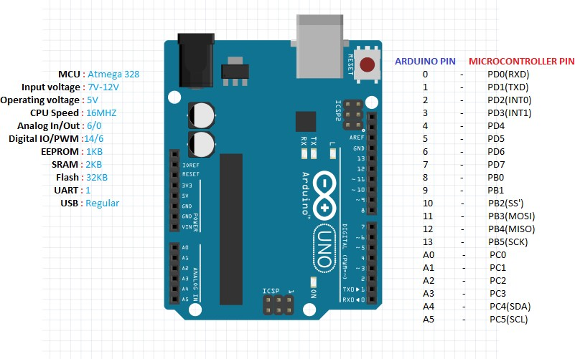Arduino Uno is an open-source microcontroller board that can be used for various projects involving electronics, robotics, sensors, and more. It is based on the ATmega328P microcontroller, which has 14 digital input/output pins, 6 analog inputs, a 16 MHz quartz crystal, a USB connection, a power jack, an ICSP header, and a reset button1. Arduino Uno can be programmed using the Arduino Software (IDE), which is a cross-platform application that supports online and offline coding. Arduino Uno can communicate with other devices using serial, SPI, I2C, or PWM protocols. Arduino Uno is compatible with many shields, modules, and sensors that extend its functionality and make it easy to create interactive and innovative projects. Arduino Uno is one of the most popular and widely used Arduino boards, as it is beginner-friendly, versatile, and affordable

Fig. 1. Arduino board.

**TABLE 1.** ENGINE-CONTROLLING TRUTH

|  |  |  |
| --- | --- | --- |
| A | B | **Function** |
| 0 | 0 | Motor shuts off |
| 0 | 1 | left |
| 1 | 0 | right |
| 1 | 1 | Motor shuts off |

Motor 2 is controlled by the table 1 pin between 10 and 15, or C and D.

TABLE 2 THE ENGINE 2 IS CONTROLLED BY TABLE 2'S TRUTH TABLE.

|  |  |  |
| --- | --- | --- |
| C | D | **Function** |
| 0 | 0 | Motor shuts off |
| 0 | 1 | Turn left |
| 1 | 0 | Turn right |
| 1 | 1 | Motor shuts off |

# 

# *B.Ultrasonic Senser:*

An ultrasonic sensor is an electronic device that measures the distance to an object by emitting ultrasonic waves and converting the reflected sound into electrical signals. Ultrasonic waves are sound waves that have frequencies higher than the human hearing range, typically above 20 kHz. The ultrasonic sensor consists of two main components: a transmitter and a receiver. The transmitter generates ultrasonic pulses using a piezoelectric crystal, which vibrates when an electric voltage is applied. The receiver detects the echoes that bounce back from the object and converts them into electrical signals. The sensor calculates the distance to the object by measuring the time interval between the emission and reception of the ultrasonic pulses the angle of reflection of the sound wave is important, as ultrasonic sensors may not detect reflected waves at high angles. Therefore, it is essential to position the sensor correctly to ensure accurate detection. Overall, the ultrasonic sensor is a reliable and versatile sensor that can be used in various applications. Its ability to detect objects at different distances and its relatively low cost make it a popular choice for robotics and automation projects.

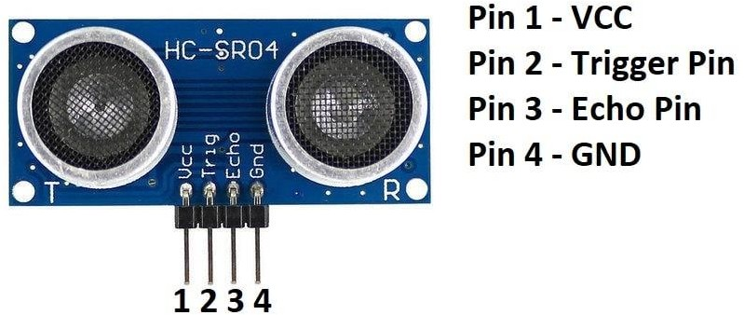

Fig. 2. Ultrasonic sensor

# *C.Servo Motor:*

Servo motors are versatile and widely used in various applications due to their precise control and ability to rotate objects to specific angles. They are often used in robotics, automation, and control systems, as well as in hobbyist projects. the servo motor is typically measuring in kg/cm, which is a measure of the amount of torque they can generate. The higher the rating, the more torque the motor can provide. The power supply for these motors usually ranges from 4.8-6V, which makes them energy-efficient and suitable for use in battery-powered devices. Three components make up a servo motor: a control device, an output sensor, and a feedback system. The control device sends a signal to the motor, which causes the output sensor to rotate to a specific angle. The feedback system then monitors the position of the output sensor and sends a signal back to the control device, which adjusts the position of the output sensor to the desired angle. Being a closed-loop system, the servo motor depends on its positive feedback system for both motion control and shaft positioning. The feedback signal, which is used to regulate the device, is created through the comparison of the output signal to the input reference signal. VCC, ground, and the signal pin are the three pins on the servo motor. The motor is powered by both the ground and VCC pins, and the signal port is linked to an Arduino PWM digital pin. The color of these pins is typically used to identify them, with the VCC pin being red, the GND pin being black, and the signal pin being white or yellow. In summary, servo motors are popular for their precise control and ability to rotate objects to specific angles. They are energy-efficient and suitable for use in various applications. The closed-loop system with feedback ensures accurate positioning, and the three pins provide easy connectivity to microcontrollers such as the Arduino.

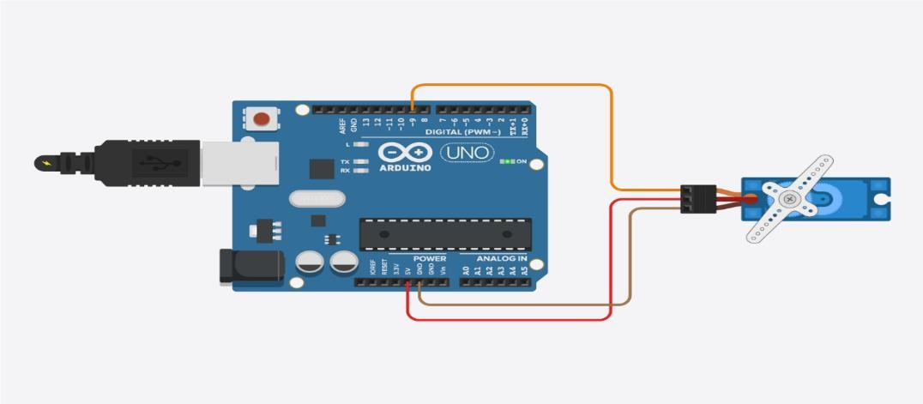

Fig. 3. Servo motor

# *D.Motor Driver:*

A motor driver component in IoT refers to a hardware device or module that controls the motion of a motor, such as a stepper or DC motor, in response to digital signals from an IoT device or system. Motor drivers are commonly used in various IoT applications, such as robotics, home automation, industrial automation, and automotive systems. They typically receive control signals from a microcontroller or other IoT device and convert them into the appropriate power levels required to drive the motor. Motor drivers of all kinds, include brush DC motors drivers, brush-less DC motor drivers, stepping motor automobile drivers, and servomotor are accessible to use in IoT applications. The kind of motor being utilised and the particular needs of the application determine the motor driver to be used. Motor drivers typically have features such as current limiting, voltage regulation, and protection against overloading and short circuits. They may also have integrated control circuitry that allows for precise control of the motor's speed, direction, and acceleration/deceleration.

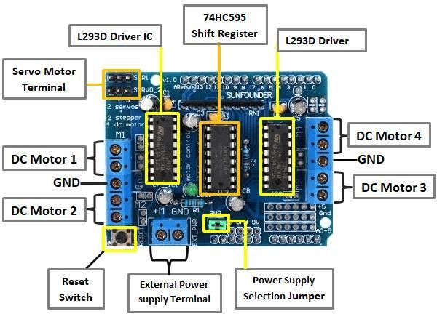

Fig. 4. Motor driver

Motor pin states are shown in Table 1.

|  |  |  |  |  |
| --- | --- | --- | --- | --- |
| **DIRECTION** | **L1** | **L2** | **L3** | **L4** |
| **FORWARD** | 1 | 0 | 0 | 1 |
| **BACKWARD** | 0 | 1 | 1 | 0 |

# *E.Bluetooth Component:*

Bluetooth communication is a wireless technology that enables the exchange of data between devices over close ranges.. It is a popular choice for IoT (Internet of Things) devices due to its low power consumption, low cost, and ease of use. In an IoT context, Bluetooth can be used as a component to connect and communicate with other devices. For example, a Bluetooth-enabled smart home device, such as a light bulb or thermostat, can be controlled from a smartphone or a hub. Bluetooth can also be used to establish a connection between a sensor and a gateway device, allowing for data to be transmitted and analyzed in real-time. Bluetooth technology is constantly evolving, and the latest version, Bluetooth 5, offers improved range, speed, and throughput compared to earlier versions. Additionally, it has capabilities like mesh networking, which enables devices to connect with one another and broadens the network's coverage. Overall, Bluetooth is a useful component in IoT devices, enabling wireless communication and data exchange between devices in a low-power, cost-effective manner.

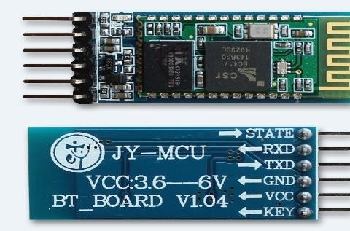

Fig. 5. Bluetooth module.

# *F.Gear Motor:*

Gearmotors are designed to simplify the process of selecting and installing a motor and gear reducer combination. By integrating the two components into a single unit, the gearmotor offers several advantages over using separate components. Firstly, gearmotors are more compact than separate motors and gear reducers, which can be particularly beneficial in applications where space is limited. Secondly, the integral gearing in a gearmotor is designed to provide the optimal gear ratio for the motor, which helps to maximize efficiency and reduce energy consumption. Finally, because the motor and gear reducer are designed and manufactured together, they are better matched and more reliable than separate components that may have been sourced from different manufacturers.

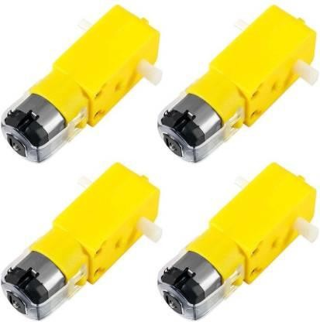

Fig. 6. Gear motor.

# *G.Robot Wheels:*

Wheeled robots are a popular type of mobile robot that use motorized wheels to move and navigate on the ground. Compared to other locomotion methods, such as treads or legs, wheeled robots are generally simpler to design, build, and program for movement. Wheels provide a number of advantages for mobile robots. They are efficient, providing a smooth and fast means of movement over a variety of surfaces, and they require less power to operate than other locomotion methods. Additionally, wheeled robots can be designed with a wide range of wheel sizes and configurations to suit different applications, from small and agile robots for indoor environments to large and rugged robots for outdoor exploration. Wheeled robots can be controlled using a variety of methods, including remote control, pre-programmed instructions, or autonomous navigation. Depending on the application, To identify and avoid obstacles or to navigate to a certain place, the robot may employ sensors like photographs, lidar, or ultrasonic sensors. With the right programming and sensors, wheeled robots can perform a wide range of tasks, from simple transportation to more complex tasks such as mapping or inspection.

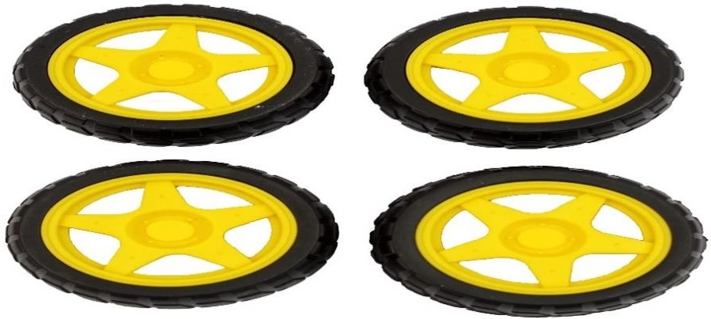

Fig. 7. Robot wheels.

# **IV.WORKING MODULE**

The human-following robot operates through a well-integrated module that combines state-of-the-art sensors, artificial intelligence algorithms, and advanced motor control systems. The sensor array includes cameras, lidar, or infrared sensors, strategically placed to capture and interpret the surrounding environment. Through sophisticated computer vision algorithms, the robot identifies and tracks the movements of a human target in real-time. The artificial intelligence component enables the robot to make instant decisions regarding its trajectory and speed, ensuring smooth and responsive navigation. The motor control system translates these decisions into precise movements, allowing the robot to dynamically follow the human subject. This cohesive module not only exemplifies the technical prowess behind the human-following robot but also underscores its potential for versatile applications in various domains, from assistive technologies to collaborative industrial settings.

**V.APPLICATION**

**Industrial Automation** The integration of a human-following robot in industrial automation represents a significant leap forward in enhancing efficiency and collaboration between humans and machines. In manufacturing environments, this innovative technology can streamline processes by autonomously transporting tools or components to human workers, reducing the need for manual material handlingThey can be programmed to move around the farm, detect obstacles like rocks or other obstacles, and avoid them to prevent damage to crops.

**Security**: Artificial intelligence algorithms enable the robot to distinguish between normal human activities and potential security threats, triggering alerts or notifications when anomalies are detected. Additionally, the robot can be integrated with other security systems, such as access control or perimeter monitoring, to create a comprehensive security infrastructure.

**Healthcare**: The integration of human-following robots in healthcare contributes to creating a more patient-centered and technologically advanced environment. By automating logistical tasks and providing support for patient care, these robots play a pivotal role in improving overall healthcare

**Education:** Obstacle detection and avoidance robots can be used in educational institutions to teach students about robotics and programming. Students can learn how to program the robot to navigate through different environments and avoid obstacles.

**Smart Cities:** These robots can be used in smart city applications for tasks like cleaning streets, monitoring traffic, and collecting data. They can navigate through city streets, detect and avoid obstacles like parked cars or pedestrians, and perform tasks autonomously.

**Disaster Response:** Obstacle detection and avoidance robots can be used in disaster response situations like search and rescue missions. They can move through debris and rubble, detect and avoid obstacles, and locate survivors.

8 Entertainment: These robots can be used in entertainment applications like theme parks or amusement parks. They can provide an interactive experience for visitors by navigating through a course, detecting and avoiding obstacles, and performing tasks.

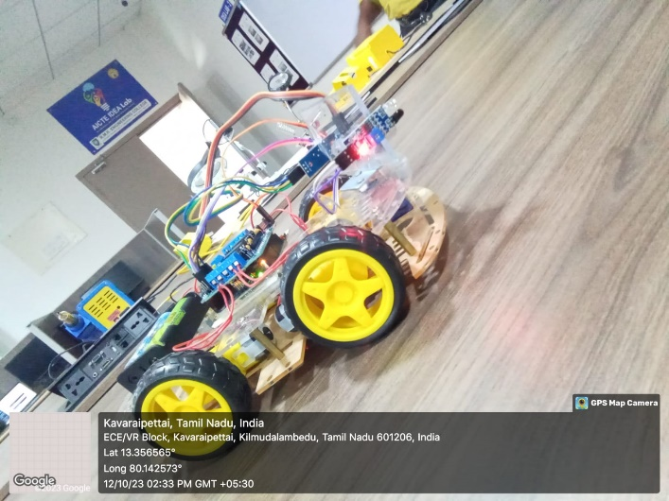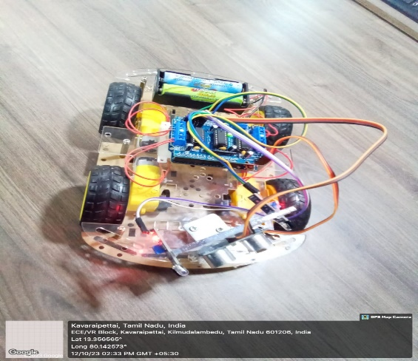

Fig. 8. Human Following robot..

8 Entertainment: These robots can be used in entertainment applications like theme parks or amusement parks. They can provide an interactive experience for visitors by navigating through a course, detecting and avoiding obstacles, and performing tasks.

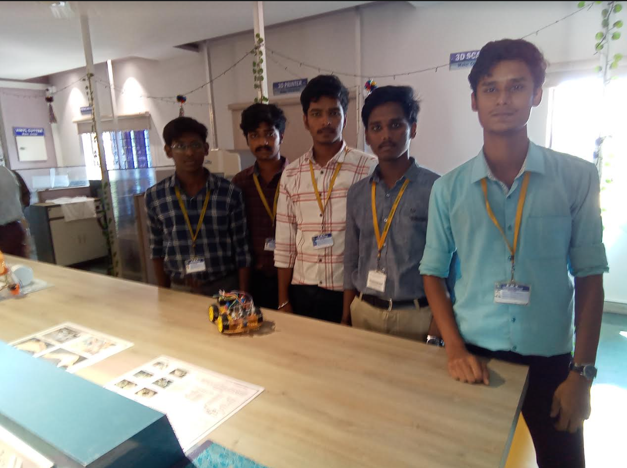

##### 

##### **VI. RESULT**

The developed robot was tested and evaluated in different environments, including indoor and outdoor environments. The robot was able to detect obstacles in its path using the ultrasonic sensors and avoid them by changing its direction. The multi-control system proved to be effective and convenient, allowing the user to control the robot using different modes. The voice mode was found to be useful in situations where the user's hands were occupied, such as when

##### **VII. CONCLUSION**

the advent of human-following robots represents a groundbreaking stride in the realms of technology, automation, and human-machine collaboration. With a sophisticated blend of sensors, artificial intelligence, and precise motor control, these robots have transcended traditional boundaries, finding applications across diverse sectors. In industrial automation, they optimize processes and foster collaboration between humans and machines, while in security, they enhance surveillance capabilities and provide a proactive approach to threat detection. Within healthcare settings, these robots streamline logistics, offer support in patient care, and contribute to a improved Society.

REFERENCES

[1] K. Morioka, J.-H. Lee, and H. Hashimoto, “Human-following mobile robot in a distributed intelligent sensor network,” IEEE Trans. Ind. Electron., vol. 51, no. 1, pp. 229–237, Feb. 2004.

[2] Y. Matsumoto and A. Zelinsky, “Real-time face tracking system for human-robot interaction,” in 1999 IEEE International Conference on Systems, Man, and Cybernetics, 1999. IEEE SMC ’99 Conference Proceedings, 1999, vol. 2, pp. 830–835 vol.2.

[3] T. Yoshimi, M. Nishiyama, T. Sonoura, H. Nakamoto, S. Tokura, H. Sato, F. Ozaki, N. Matsuhira, and H. Mizoguchi, “Development of a Person Following Robot with Vision Based Target Detection,” in 2006 IEEE/RSJ International Conference on Intelligent Robots and Systems, 2006, pp. 5286–5291.

[4] H. Takemura, N. Zentaro, and H. Mizoguchi, “Development of vision based person following module for mobile robots in/out door environment,” in 2009 IEEE International Conference on Robotics and Biomimetics (ROBIO), 2009, pp. 1675–1680.

[5] N. Bellotto and H. Hu, “Multisensor integration for humanrobot interaction,” IEEE J. Intell. Cybern. Syst., vol. 1, no. 1, p. 1, 2005.

[6] W. Burgard, A. B. Cremers, D. Fox, D. Hähnel, G. Lakemeyer, D. Schulz, W. Steiner, and S. Thrun, “The interactive museum tour-guide robot,” in AAAI/IAAI, 1998, pp. 11–18.

[7] M. Scheutz, J. McRaven, and G. Cserey, “Fast, reliable, adaptive, bimodal people tracking for indoor environments,” in Intelligent Robots and Systems, 2004.(IROS 2004). Proceedings. 2004 IEEE/RSJ International Conference on, 2004, vol. 2, pp. 1347–1352. [8] N. Bellotto and H. Hu, “People tracking and identification with a mobile robot,” in Mechatronics and Automation, 2007. ICMA 2007. International Conference on, 2007, pp. 3565– 3570.

[9] S. Jia, L. Zhao, and X. Li, “Robustness improvement of human detecting and tracking for mobile robot,” in Mechatronics and Automation (ICMA), 2012 International Conference on, 2012, pp. 1904–1909.

[10] N.-Y. Ko, D.-J. Seo, and Y.-S. Moon, “A Method for Real Time Target Following of a Mobile Robot Using Heading and Distance Information,” J. Korean Inst. Intell. Syst., vol. 18, no. 5, pp. 624–631, Oct. 2008.

[11] T. Wilhelm, H. J. Böhme, and H. M. Gross, “Sensor fusion for vision and sonar based people tracking on a mobile service robot,” in Proceedings of the International Workshop on Dynamic Perception, 2002, pp. 315–320. [12] D. Calisi, L. Iocchi, and R. Leone, “Person following through appearance models and stereo vision using a mobile robot.,” in VISAPP (Workshop on on Robot Vision), 2007, pp. 46–56.

[13] A. Ess, B. Leibe, and L. Van Gool, “Depth and appearance for mobile scene analysis,” in Computer Vision, 2007. ICCV 2007. IEEE 11th International Conference on, 2007, pp. 1–8.

[14] A. Ess, B. Leibe, K. Schindler, and L. Van Gool, “A mobile vision system for robust multi-person tracking,” in Computer Vision and Pattern Recognition, 2008. CVPR 2008. IEEE Conference on, 2008, pp. 1–8.

[15] Y. Salih and A. S. Malik, “Comparison of stochastic filtering methods for 3D tracking,” Pattern Recognit., vol. 44, no. 10, pp. 2711–2737, 2011.

[16] R. Muñoz-Salinas, E. Aguirre, and M. García-Silvente, “People detection and tracking using stereo vision and color,” Image Vis. Comput., vol. 25, no. 6, pp. 995–1007, 2007.

[17] J. Satake and J. Miura, “Robust stereo-based person detection and tracking for a person following robot,” in ICRA Workshop on People Detection and Tracking, 2009. [18] J. H. Lee, T. Tsubouchi, K. Yamamoto, and S. Egawa, “People Tracking Using a Robot in Motion with Laser Range Finder,” in 2006 IEEE/RSJ International Conference on Intelligent Robots and Systems, 2006, pp. 2936–2942.

[19] M. Lindstrom and J. O. Eklundh, “Detecting and tracking moving objects from a mobile platform using a laser range scanner,” in 2001 IEEE/RSJ International Conference on Intelligent Robots and Systems, 2001. Proceedings, 2001, vol. 3, pp. 1364–1369 vol.3.

[20] K. S. Nair, A. B. Joseph, and J. I. Kuruvilla, “Design of a low cost human following porter robot at airports.”